**Project Documentation**

**Rythmic tunes,your melodies of companison**

**1.Introduction**

# ✓ Project Title: Rythmics tunes,your melodies of compansion

❖ **Team ID:NM2025TMID31582**  **Team Leader:**

➢ NAME: SARANYA R

MAIL ID: saranyaramar787@gmail.com

❖ **Team Members**

* NAME:MAHALAKSHMI S

MAIL ID: magalakshmi18062007@gmail.com

* NAME:SANGAVI G

MAIL ID: sangavignanavel@gmail.com

* NAME: LALITHAVALLI M

MAIL ID: lalithavalli6@gmail.com

# 2. Project Overview

❖ **Purpose:** Rhythmic Tunes:Your Melodic Companion Rhythmic Tunes is designed to bring music into every moment of your life.

It serves as a companion that lifts your mood with melodies.

The tunes are crafted to match your rhythm, energy, and emotions.

It provides relaxation, focus, or celebration through sound. Ultimately, it’s your personal guide to a harmonious musical journey.

❖ **Features:**

* Personalized playlists for every mood.
* Soothing tunes to relax and refresh.
* Energetic beats to keep you motivated.
* Your constant musical partner anytime, anywhere.Secure chat system.

**3. Architecture**

❖ Frontend: React.js with Bootstrap and Material UI

# 4. Setup Instructions

❖ **Prerequisites:**

* Node.js
* Git
* React.js
* Express.js – Visual Studio Code  **Installation Steps:**

# Clone the repository git clone # Install client dependencies cd client npm install

# Install server dependencies cd

../server npm install

# 5. Folder Structure

SB-Works/

|-- client/ # React frontend

|__components/

L__ pages/

# |__ server/ # Node.js 6. Running the Application

❖ **Frontend:**

* cd client
* npm start

❖ **Access: Visit** [**http://localhost:3000**](http://localhost:3000/)

# 7. API Documentation

❖ **User:**

* /api/user/register • /api/user/login  **Projects:**
* /api/projects/create
* /api/projects/:id • Applications: /api/apply

❖ **Chats:**

* /api/chat/send
* /api/chat/:userId

# 8. Authentication

* **JWT-based authentication for secure login**
* **Middleware protects private routes**

# 9. User Interface

* Landing Page
* Freelancer Dashboard
* Admin Panel
* Project Details Page

# 10. Testing

* Manual testing during milestones
* Tools: Postman, Chrome Dev Tools

# 11. Screenshots

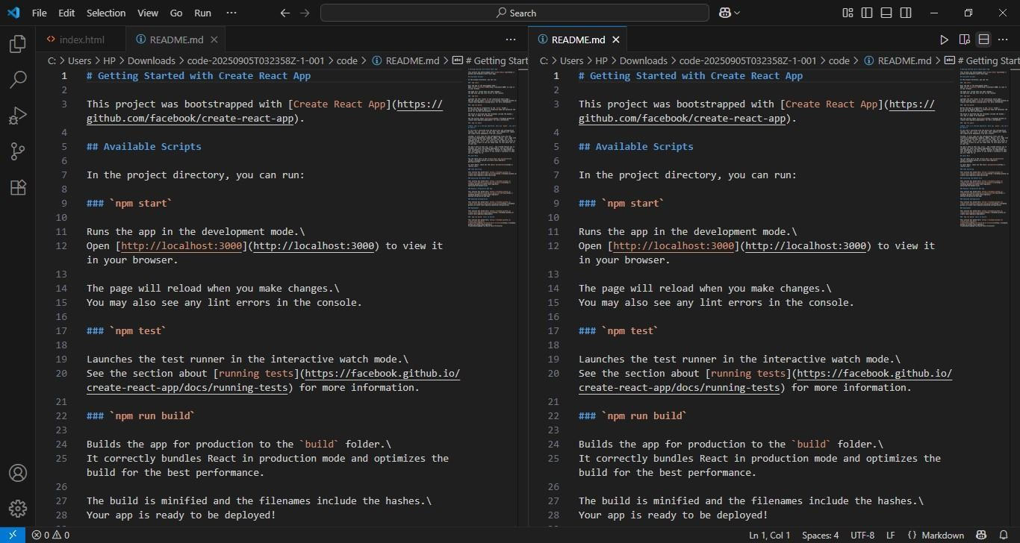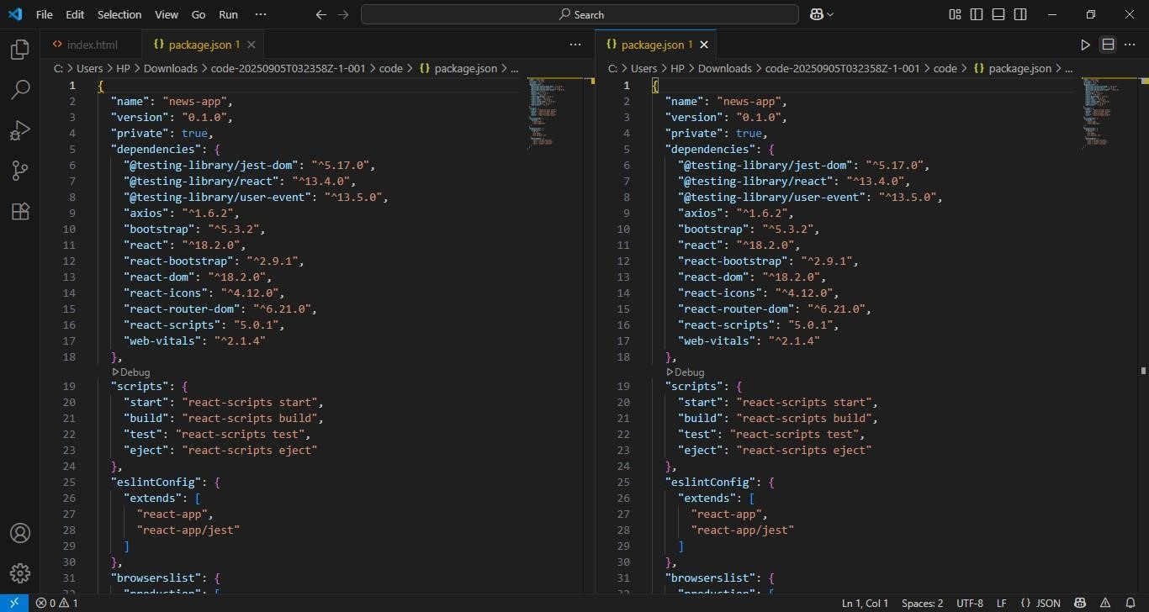

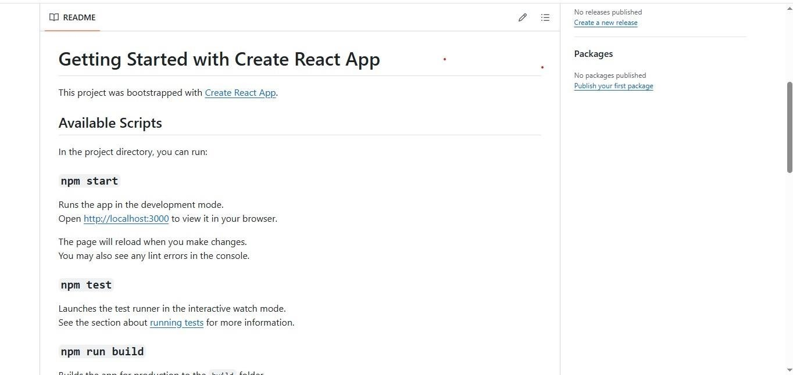

1. Known **Issues**
   * API Rate Limits
   * Server Problem
   * Navigation Glitches
2. Future Enhancements
   * Analytics Dashboard
   * Search Functionality
   * User Authentication